1. Context

1.1 Brief system description
Amplio is a collaborative music playlist platform that is built on an ASP.NET Core (.NET 9) backend, a React frontend, and a PostgreSQL database - all containerised with Docker and hosted (managed by Coolify). Users create public or private playlists, queue songs from a YouTube catalogue, vote for tracks to influence playback order, and browse ranked leaderboards.

1.2 Changes made
This iteration introduced the new Friend System as a vertical slice across all of the architecture layers. The additions are summarised below:
Layer | Element added | Functionality
Inbound pipeline | Rate Limiter | Caps social operations at 20 friend requests per user per hour
Controller | FriendsController | Exposes /friends/* endpoints: send, cancel, accept, decline, block, search users, list friends, invite to playlist
Service | FriendService | Enforces friend-request lifecycle rules, block checks, and invitation eligibility
Repository | FriendRepository | Persists FriendRequest, Friendship, and Block records. Executes status-based queries
Database | Three new tables | FriendRequests, Friendship, Blocks - added via EF Core migration
Concurrency | Unique constraint | (LEAST(SenderId,ReceiverId), GREATEST(SenderId,ReceiverId)) prevents reciprocal duplicate requests at database level
Playlist | Invitation flow | A host may invite a confirmed friend to a private playlist without a join code; FriendService verifies the active Friendship before PlaylistService grants access

1.3 Technical constraints & assumptions
Structural constraints:
- No staging environment — all changes go directly to production. A faulty migration requires manual image rollback and database restore from backup.
- Single-VPS deployment, meaning no horizontal scaling. SemaphoreSlim vote lock is in process and would not be able to survive multiple instance deployment.

Risks:
- No automated database backups.
- No token revocation - JWT tokens remain valid for 12 hours after issuance; a stolen token cannot be invalidated before expiry.
- No observability stack - there is no structured logging, health endpoint, or alerts. Outages are detected by user reports.

Assumptions:
- All users are authenticated via JWT before reaching any controller.
- The external YouTube link catalogue is read-only from Amplio’s perspective (songs and albums are not created by the user).
- User account deletion is out of scope for this iteration. Cleanup of Friendship/FriendRequest records is not implemented.

2. View

2.1 Functional View

2.1.1. Overview
The Functional view describes the system's runtime functional elements and their responsibilities, interfaces, and primary interactions. It is the cornerstone of most architectural descriptions and drives the shape of other views such as the Information, Concurrency, and Deployment views.

2.1.2. Concerns
The Functional viewpoint addresses the following concerns: functional capabilities, external interfaces, internal structure, and design philosophy.
Applied to Amplio:
- Functional capabilities - what the system does from a user perspective: authentication, playlist management, collaborative voting, leaderboards, and the new Friend System.
- External interfaces - the REST API exposed to the React frontend; the PostgreSQL database as a downstream dependency; the external YouTube link catalogue.
- Internal structure - how responsibilities are distributed across the four layers: the request pipeline, controllers, services, and repositories.
- Design philosophy - the principles guiding the functional design: separation of concerns between layers, dependency on abstractions rather than concrete implementations, and single-responsibility allocation to each element.

2.1.3. Models
- The primary model for the Functional viewpoint is the functional structure model. It shows the system's runtime elements as components, their interfaces, and the dependencies between them.
- A functional element is a well-defined part of the runtime system that has particular functional responsibilities and exposes interfaces. Infrastructure should not be modelled here unless it performs a functionally significant purpose.
- Amplio's functional elements are grouped into four layers:
Inbound Request Pipeline
Element | Responsibility
HTTPS / CORS Middleware | Enforces encrypted communication and cross-origin access policy
JWT Authentication Middleware | Validates bearer tokens; injects authenticated user identity into the request context; returns HTTP 401 on failure
Rate Limiter | Enforces per-user limits on social operations to prevent abuse
Presentation Layer - Controllers

Element | Responsibility | Interface
AuthController | User registration and login; JWT token issuance | POST /auth/register, POST /auth/login
PlaylistController | Playlist lifecycle, song queue, visibility management, invitations | /playlists/*
SongsController | Song catalogue access and upvoting | /songs/*
AlbumsController | Album browsing and popularity ranking | /albums/*
LeaderboardController | Ranked views of playlists and albums | /leaderboard/*
FriendsController (new) | Friend requests, blocking, user search, friends list, playlist invitations | /friends/*

Application Layer - Services
Element | Responsibility
AuthService | Credential validation, password hashing, JWT issuance
PlaylistService | Playlist access rules, song queue management, active song promotion
SongService | Song catalogue access, vote count management with concurrency control
AlbumService | Album data aggregation and popularity computation
LeaderboardService | Ranked list generation from visit counts and vote aggregates
FriendService (new) | Friend request lifecycle, blocking rules, user search visibility, invitation eligibility
Infrastructure Layer - Repositories

Element | Responsibility
UserRepository | User account persistence; username-based search
PlaylistRepository | Playlist and playlist-song records, vote counts, song ordering
SongRepository | Song catalogue access
AlbumRepository | Album records and song associations
FriendRepository (new) | FriendRequest, Friendship, and Block record persistence; status-based queries

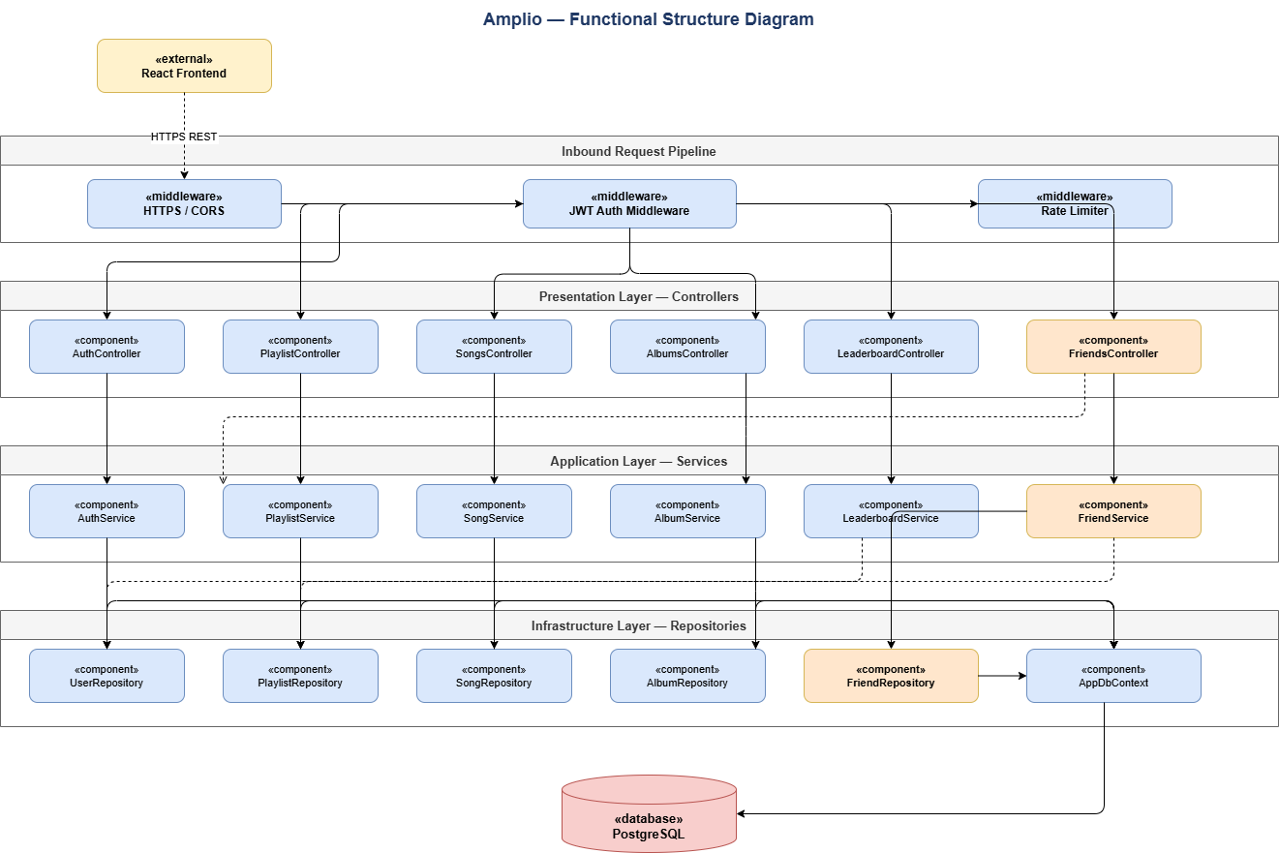2.1.4. Key Functional Interactions
User Authentication A client submits credentials to AuthController, which delegates to AuthService. AuthService retrieves the user record via UserRepository, verifies the password against the stored hash, and returns a signed JWT token on success. All subsequent requests carry this token, validated by JWT Middleware before reaching any controller.
Playlist and Song Queue PlaylistController receives a playlist request and delegates to PlaylistService, which retrieves the playlist and its song queue from PlaylistRepository. Upvote requests are processed by SongService with concurrency control to ensure correctness under simultaneous updates. When the active song is promoted, PlaylistService updates the playlist state.
Friend Request Lifecycle FriendsController receives a friend request from an authenticated user and delegates to FriendService. FriendService verifies that no block exists between the parties and no duplicate request is pending. A FriendRequest in Pending state is persisted via FriendRepository. The receiver may accept (creating a Friendship), decline, or block the sender. The sender may cancel before a response.
Playlist Invitation A playlist host invites a friend via FriendsController. FriendService verifies that an active Friendship exists. PlaylistService grants the invitee direct access to the private playlist without a join code.

2.1.5. Friend Request State Model

From State | Transition | Initiated By | Effect
Pending | accept() | Receiver | Friendship record created; both users connected
Pending | decline() | Receiver | Request rejected; future requests permitted
Pending | cancel() | Sender | Request withdrawn before response
Pending | block() | Receiver | Sender permanently blocked; existing Friendship removed; future requests prevented
Accepted | removeFriend() | Either user | Friendship record deleted

2.1.6. Problems and Pitfalls Addressed
Known pitfalls of the Functional viewpoint include: poorly defined interfaces, poorly understood responsibilities, infrastructure modelled as functional elements, overloaded view, diagrams without element definitions, difficulty in reconciling the needs of multiple stakeholders, inappropriate level of detail, "God elements," and too many dependencies.
The Amplio functional structure addresses these as follows: each element has a single well-defined responsibility; interfaces are explicitly listed per controller; infrastructure elements (PostgreSQL, Docker, Kestrel) are not modelled as functional elements; the layered structure keeps inter-element dependencies strictly unidirectional.

2.2 Information View

2.2.1. Overview
The Information viewpoint describes how the system stores, manipulates, manages, and distributes information. The objective of this analysis is to answer the big questions around content, structure, ownership, latency, references, and data migration.

2.2.2. Concerns
The Information viewpoint addresses the following concerns: information structure and content; information flow; data ownership; timeliness, latency, and age; references and mappings; transaction management and recovery; data quality; data volumes; archives and data retention; and regulation.
Applied to Amplio:
- Information structure and content - what entities exist, their attributes, and how they relate.
- Information flow - how data moves through the system during authentication, playlist retrieval, and social operations.
- Data ownership - which service is responsible for creating, updating, and deleting each entity.
- Data quality - integrity constraints, uniqueness rules, and consistency requirements.
- Timeliness and latency - performance targets for friend and search operations.

2.2.3. Models
Models used in the Information viewpoint include: static data structure models, information flow models, information lifecycle models, data ownership models, data quality analysis, metadata models, and volumetric models.
Static Data Structure Model
Existing Entities

Entity | Key Attributes | Description
User | Id, Username, PasswordHash, PasswordSalt | Registered platform user. Username is unique. Password stored as salted hash
Playlist | Id, Name, IsPublic, OwnerId, Popularity, CurrentSongId | Named song collection with public/private visibility
Song | Id, Title, Artist, Link, AlbumId | Track in the catalogue with a normalised external link
PlaylistSong | PlaylistId, SongId, Votes, AddedAt | Join entity carrying per-song vote count and timestamp
Album | Id, Name, Artist, ReleaseYear, Popularity | Groups songs by release; carries aggregated popularity
New Entities (This Iteration)

Entity | Key Attributes | Description
FriendRequest (new) | Id, SenderId, ReceiverId, Status, SentAt | Request between two users; Status: Pending / Accepted / Declined / Cancelled / Blocked
Friendship (new) | Id, UserId, FriendId, CreatedAt | Confirmed mutual friendship; created on accept, deleted on unfriend or block
Block (new) | Id, BlockerId, BlockedId, CreatedAt | Block record; prevents future requests; removes any existing Friendship
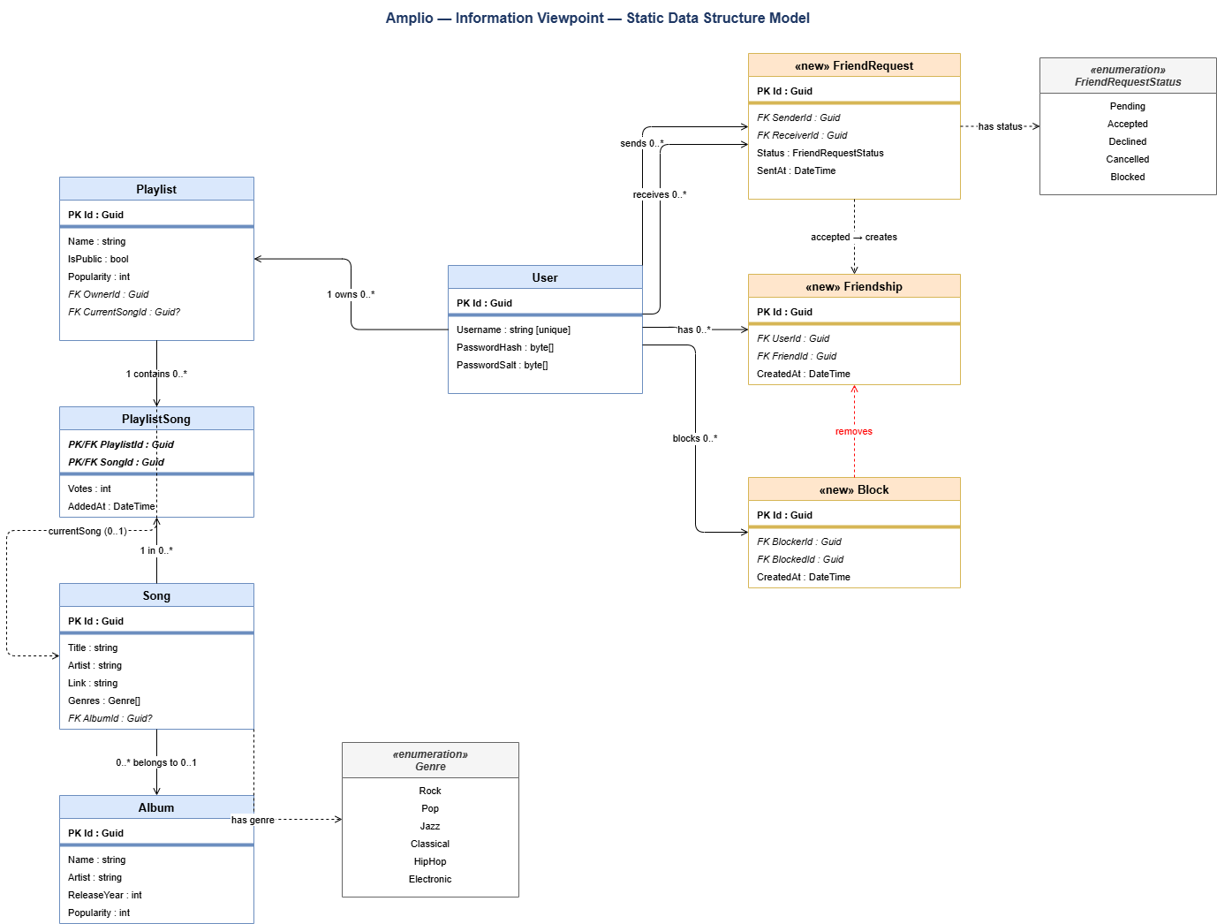

2.2.4. Data Ownership

Entity | Owner | Notes
User | AuthService | Created on registration; deletion out of scope
Playlist | PlaylistService | Created and deleted by owner; songs managed by invited members
Song / Album | SongService / AlbumService | Loaded from catalogue; not user-created
PlaylistSong | PlaylistService | Created on add; deleted on remove; votes updated on upvote
FriendRequest | FriendService | Created by sender; status updated by either party
Friendship | FriendService | Created on accept; deleted on unfriend or block
Block | FriendService | Created by blocker; triggers Friendship deletion

2.2.5. Information Flow
Authentication: Client credentials -> AuthService validates via UserRepository -> JWT token returned. No password data transmitted beyond initial login.
Playlist Retrieval: PlaylistService fetches Playlist and PlaylistSong records -> song metadata joined from SongRepository -> complete playlist with votes returned. Private playlists restricted to owner and invited users.
Friend Request: FriendService reads Block and FriendRequest records to check preconditions -> new FriendRequest written in Pending state -> on accept, Friendship written -> on block, existing Friendship deleted, Block written.

2.2.6. Data Quality

Property | How Addressed
Integrity | Foreign key constraints enforced by PostgreSQL; Block creation triggers Friendship removal
Consistency | Vote updates use concurrency control; friend operations execute within transactions
Uniqueness | Username unique constraint; at most one active FriendRequest per user pair
Indexing | Foreign key columns on FriendRequest, Friendship, Block indexed for query performance
Privacy | No sensitive data exposed via API; blocked users excluded from search results

2.2.7. Problems and Pitfalls Addressed
Known pitfalls of the Information viewpoint include: data incompatibilities, poor data quality, unavoidable multiple updaters, key matching deficiencies, poor information latency, interface complexity, and inadequate volumetrics.
Amplio addresses these through: foreign key constraints and EF Core migrations ensuring structural integrity; indexed columns on all join-table foreign keys meeting the 1–2 second performance targets; concurrency control on vote updates preventing lost updates.

2.3 Concurrency View

2.3.1 State diagrams

FriendRequest state diagram
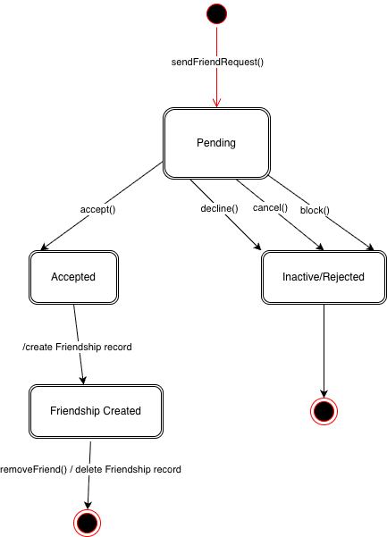

Once sent, the friend request starts in Pending. From there it can be accepted, declined, or cancelled by the sender. Declining and cancelling both lead to the same Inactive/Rejected terminal state, as they result in the same outcome - the request is no longer active. If the receiver blocks the sender, the request transitions to Blocked, which is a distinct state as it carries the side effect of preventing the blocked user from sending any future requests to that person. Acceptance automatically creates a Friendship record. The friendship remains active until removeFriend() is called, which deletes the Friendship record and terminates the relationship.

Playlist state diagram
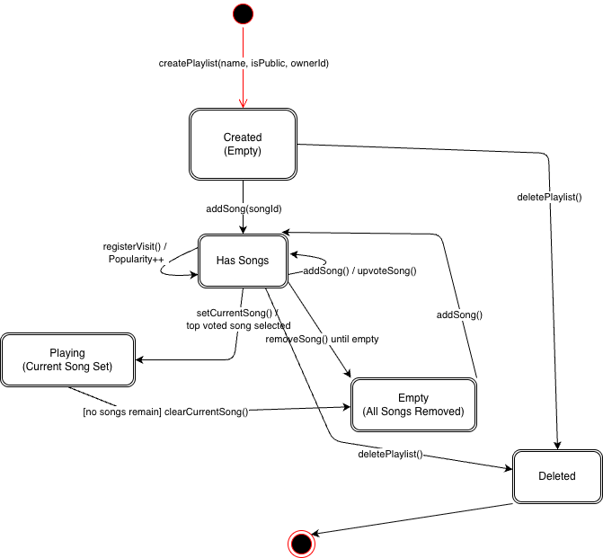
A newly created playlist starts in the Created (Empty) state. Adding the first song moves it to Has Songs, where voting happens and visits trigger a Popularity++ self-transition without leaving the state. Calling setCurrentSong() picks the top-voted song, sets it as active, and removes it from the queue - moving the playlist to Playing. If songs remain after playback it goes back to Has Songs, otherwise it transitions to Empty (All Songs Removed). Deleting a playlist from any state - whether Created, Empty, or Playing - transitions it to the Deleted state before terminating.

2.3.2 Sequence diagram
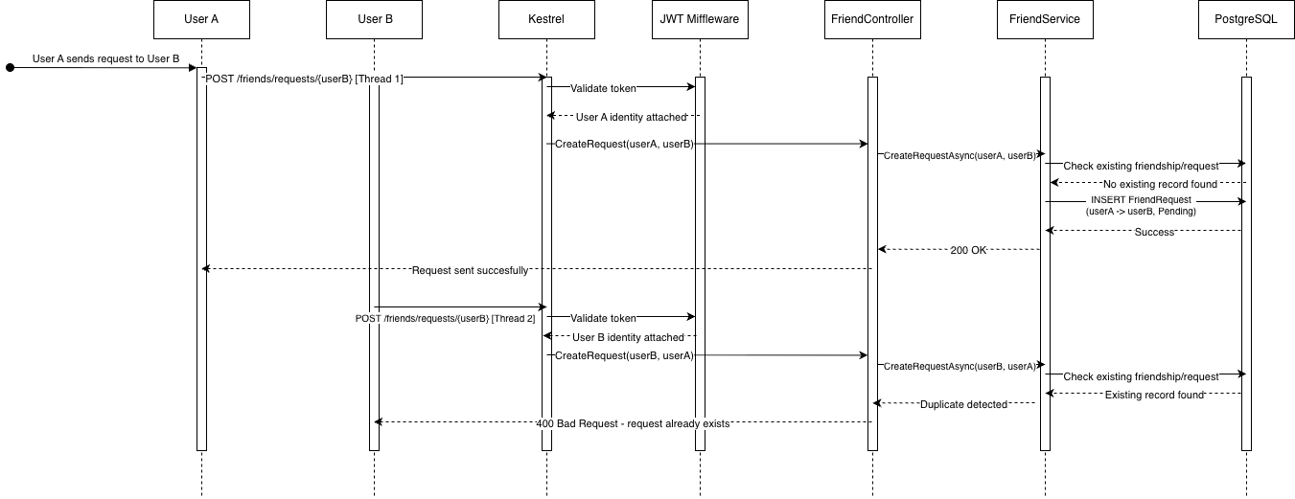
The sequence diagram illustrates a concurrency scenario in the Friend System where two users simultaneously send each other a friend request, running on separate Kestrel threads. Both requests pass through JWT Middleware concurrently, each receiving their respective user identity. They then reach FriendService at the same time, where each checks the database for an existing friendship or pending request. Thread 1 (User A -> User B) arrives first, finds no existing record, and successfully inserts a new FriendRequest with Pending status. Thread 2 (User B -> User A) arrives moments later, finds the record already created by Thread 1, and is rejected with a 400 Bad Request response. Duplicate prevention relies on the service-layer check, a unique constraint on (LEAST(SenderId, ReceiverId), GREATEST(SenderId, ReceiverId)) acts as the database-level safety net for both same-direction and reciprocal duplicates. On constraint violation the second request returns 400 Bad Request.

2.3.3 Task structure
The Amplio backend runs on ASP.NET Core hosted by Kestrel, which manages a thread pool and assigns each incoming HTTP request to its own thread. All Friend System endpoints are fully asynchronous - controller and service methods use async/await throughout, meaning threads are released back to the pool while awaiting database responses from EF Core, rather than blocking. This allows the server to handle multiple concurrent friend requests, votes, and playlist operations without thread starvation.
All controllers, services, and repositories execute within a single backend process (Kestrel) inside one Docker container. There are no worker processes, background services, or scheduled jobs. The vote-count cache (ConcurrentDictionary) and the vote-update lock (SemaphoreSlim) are process-local - they do not survive container restarts and are not shared with any other process.

2.3.4 Synchronization and integrity
Concurrent vote updates are the primary synchronization concern in the system. A SemaphoreSlim(1,1) serialises access to vote count updates, ensuring only one thread modifies a song's vote count at a time. Vote counts are cached in a ConcurrentDictionary to reduce database load under high concurrency. Friend request operations do not use explicit locking - instead, duplicate prevention is enforced at the service layer by checking for existing records before insertion, with a unique constraint on (SenderId, ReceiverId) in the database acting as the final guarantee of integrity.

2.3.5 State managment
FriendRequest state transitions are managed exclusively through EF Core database updates, ensuring atomicity. A request moves from Pending to Accepted, Inactive/Rejected, or Blocked - each transition is a single atomic UPDATE operation. Accepting a request additionally creates a Friendship record in the same transaction, so it is impossible to have an Accepted FriendRequest without a corresponding Friendship record. Playlist state similarly relies on atomic DB operations, with setCurrentSong() selecting the top-voted song and removing it from the queue in a single operation.

2.3.6 Potential concurrency risks
The primary concurrency risk is two users simultaneously sending each other friend requests, as demonstrated in the sequence diagram above. This is mitigated by the unique constraint on (SenderId, ReceiverId), which guarantees at the database level that only one record can exist between any two users. A secondary risk is vote count inconsistency under high load - mitigated by SemaphoreSlim as described in section 2.3.4. No distributed locking mechanism is currently in place, but would need to be addressed if the system were scaled horizontally in the future.

2.4 Development View

2.5 Deployment View
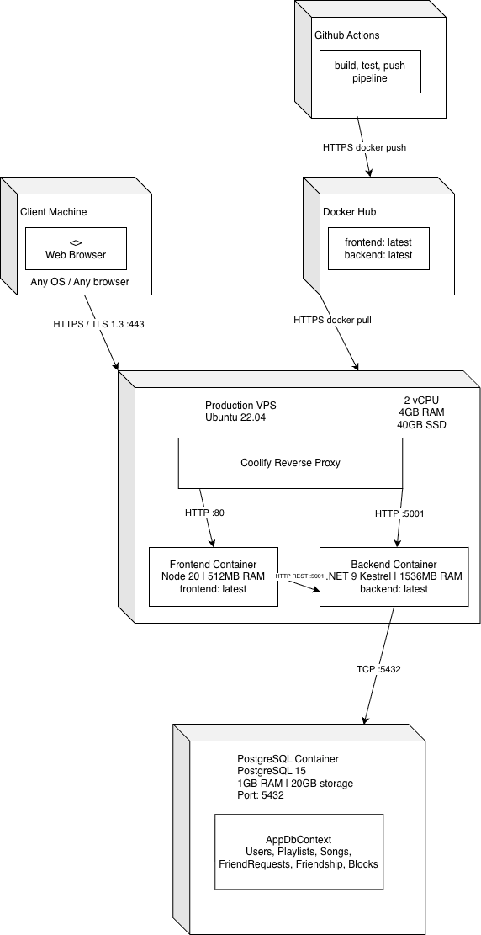
The Client Machine hosts the user's web browser, which communicates with the system over HTTPS/TLS 1.3 on port 443. The Production VPS (Ubuntu 22.04, 2 vCPU, 4GB RAM, 40GB SSD) is the main runtime environment. It contains the Coolify reverse proxy, which routes incoming traffic - requests to / are forwarded to the Frontend Container (Node 20, 512MB RAM) and requests to /api are forwarded to the Backend Container (.NET 9 Kestrel, 1.5GB RAM). The frontend communicates with the backend internally over HTTP on port 5001. The PostgreSQL Container (PostgreSQL 15, 1GB RAM, 20GB storage) runs separately and is accessed by the backend over TCP on port 5432. It hosts the AppDbContext with all application tables including the new FriendRequests, Friendships, and Blocks tables introduced in this iteration. The CI/CD flow runs independently - GitHub Actions builds, tests, and pushes Docker images to Docker Hub over HTTPS. When a deployment is triggered, Coolify pulls the latest images from Docker Hub and restarts the containers, injecting environment variables and running any pending EF Core migrations.

2.6 Operational View
The Operational viewpoint describes how the system is installed, upgraded, monitored, configured, backed up, and supported in its production environment.

Installation and Upgrade
There is no manual installation procedure. When a pull request is merged to main, GitHub Actions builds and pushes new Docker images to Docker Hub. Coolify receives a webhook, pulls the latest images, restarts the containers, injects environment variables, and automatically runs any pending EF Core migrations. Schema changes introduced in this iteration (the FriendRequests, Friendships, and Blocks tables) are applied this way without manual steps.

There is no staging environment - all changes go directly to production. If a migration is faulty, the database must be manually restored from a backup and the image rolled back to the previous backup.

Monitoring and Control
Coolify monitors container liveness and restarts crashed containers automatically. Beyond this, there is no observability stack - no structured logging, no application health endpoint, no metrics dashboard, and no error alerting.

Configuration Management
All runtime configuration is managed as environment variables injected by Coolify at startup. Secrets are not committed to the repository.

Variable | Purpose
ConnectionStrings__Default | PostgreSQL connection string
Jwt__Key | HMACSHA256 signing key

Backup and Restore
The PostgreSQL container uses a 10 GB Docker volume on the VPS. No automated backup is configured. A VPS hardware failure or volume corruption would cause total data loss.
The recommended fix is a nightly pg_dump exported off-host. Manual restore procedure:
- Stop the backend container.
- Drop and recreate the database.
- Run pg_restore from the latest dump.
- Restart the backend - EF Core will verify schema state on startup.

Support
The system is operated directly by the development team through the Coolify dashboard. There is no admin panel; any data correction requires a direct SQL statement via Coolify's terminal access.
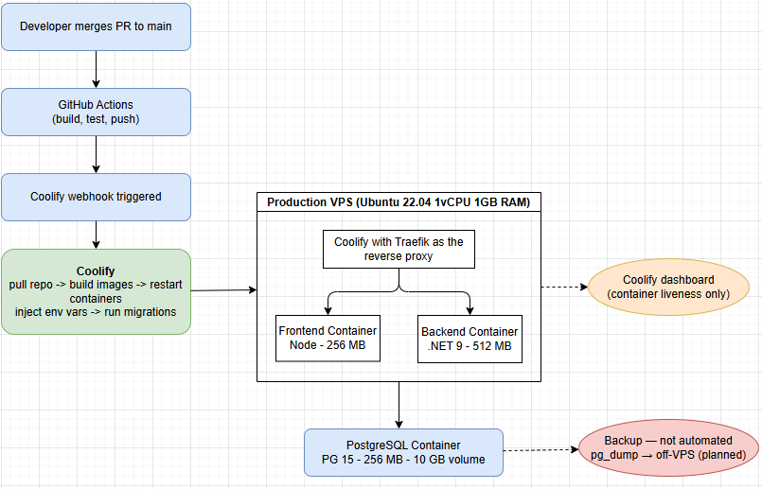

3. Perspectives

3.1 Security

Overview
Security is defined as the set of processes and technologies that allow the owners of resources in the system to reliably control who can perform what actions on particular resources. Security is not a binary state but a process of risk management that balances likely risks against the costs of guarding against them.
The security perspective is applied across all views because authentication, access control, and data protection are cross-cutting concerns that affect the functional structure, the information model, and the runtime environment.

3.1.1 Applied to the Functional View
The JWT Auth Middleware is the first functional element that processes every incoming request. No request reaches any controller without passing through authentication. This means security is enforced at the pipeline boundary, not inside individual controllers or services - avoiding the pitfall of security embedded in application code.
FriendsController and FriendService enforce access control at the service layer: before any friend request is created, FriendService checks whether a Block record exists between the two parties. Before any playlist invitation is issued, FriendService verifies that an active Friendship exists. The Rate Limiter enforces a limit of 20 friend requests per user per hour at the pipeline level, preventing request flooding.
The layered architecture supports the principle of defence in depth: HTTPS at transport, JWT at the pipeline boundary, access checks at the service layer, and database constraints as the final safety net.

3.1.2 Applied to the Information View
The sensitive resources in the system are: user credentials (PasswordHash, PasswordSalt), private playlist content, and social graph data (Friendship and Block records).
Password data is stored as a salted HMACSHA256 hash. No API endpoint returns PasswordHash or PasswordSalt - these fields are never included in any response DTO. This ensures that a database read does not translate into credential exposure.
The Block entity enforces information hiding at the data level: blocked users are excluded from user search results by a filter applied in FriendService before any query result is returned. The blocker's playlists are similarly excluded from the blocked user's view.
FriendRequest records are retained after resolution (Accepted, Declined, Cancelled, Blocked) rather than deleted. This provides an implicit audit trail of social interactions, which supports accountability.

3.1.3 Applied to the Concurrency View
Concurrent friend requests between the same pair of users are prevented by a unique constraint on (SenderId, ReceiverId) at the database level. A duplicate check is performed at the service layer before any INSERT, with the database constraint acting as the final guarantee. This prevents a race condition where two simultaneous requests from the same sender could both pass the service-layer check and insert duplicate records.
JWT validation is stateless - each request carries its own token and the middleware validates it independently, without shared mutable state. This means concurrent requests from the same user do not contend on any authentication resource.

3.1.4 Applied to the Deployment View

3.1.5 Applied to the Development View

3.1.6 Applied to the Operational View
There is no admin panel. Any privileged data operation requires direct SQL access via the Coolify terminal. This limits the attack surface - there is no web-accessible admin interface that could be exploited - but it also means there are no operational security controls such as audit logging of administrative actions.
JWT tokens have a 12-hour expiry. There is no token revocation mechanism. A stolen token remains valid until expiry. This is an accepted risk at the current scale; a production system would require a token blacklist or short-lived refresh token pattern.

3.2 Performance & Scalability

3.2.1 Applied to the Functional View
All Friend System endpoints in FriendsController and FriendService are fully asynchronous, implemented using async/await throughout the controller, service, and repository layers. This means that when FriendService awaits a database response from EF Core, the Kestrel thread is released back to the thread pool and can serve another request in the meantime. Without this, each pending database query would occupy a thread and the server would quickly exhaust its thread pool under moderate concurrency. The tradeoff is increased code complexity compared to synchronous implementations, but this is standard practice in ASP.NET Core and well understood by the team.

3.2.2 Applied to the Information View
The three new tables introduced in this iteration - FriendRequest, Friendship, and Block - all have indexed foreign key columns on SenderId, ReceiverId, UserId, and FriendId. Without indexes, every duplicate check or friend lookup would require a full table scan, which would grow linearly with the number of users and quickly violate the 1 second response requirement. Username search is backed by a unique constraint and index on the Username column, ensuring search queries remain fast regardless of total user count. The tradeoff is slightly slower INSERT operations and additional storage overhead, which is negligible at the current scale.

3.2.3 Applied to the Concurrency View
Vote counts are cached in a ConcurrentDictionary rather than being read from the database on every request. This significantly reduces database load under concurrent voting, as multiple threads can read the cached count without hitting PostgreSQL. SemaphoreSlim(1,1) serialises write operations to vote counts, ensuring correctness but introducing a bottleneck - only one thread can update a song's vote count at a time. This is acceptable for the current single-instance deployment but would become a performance concern under high voting load.

3.2.4 Applied to the Development View

3.2.5 Applied to the Deployment View
The entire system runs on a single VPS with 2 vCPU and 4GB RAM shared across the Coolify reverse proxy, frontend container (512MB RAM), backend container (1.5GB RAM), and PostgreSQL container (1GB RAM). The container caps sum to ~3GB, leaving ~1GB for the host OS and reverse proxy - enough headroom to absorb moderate traffic spikes without OOM events. Horizontal scaling is still not possible because SemaphoreSlim is in-process and would not synchronise across multiple backend instances, and there is no distributed cache or message broker in place. The current architecture can therefore only scale vertically (larger VPS), and only up to the point where the single backend process saturates the available cores. This constraint is accepted given the academic context and current user scale, but any significant growth in users would require migrating to a managed database, introducing a distributed cache such as Redis, and replacing in-process synchronisation with distributed locking (e.g. Redis-backed locks or a database-level advisory lock).

3.2.6 Applied to the Operational View

3.3 Availability & Resilience

Overview
The entire system runs on a single VPS - one machine, one network path, one database volume. There is no redundancy at any layer. This is the defining constraint on availability and shapes every answer in this section. It is accepted given the academic context.

Unplanned Downtime
Failure | Mitigation | Residual Risk
Backend container crash | Coolify auto-restart | Persistent crash requires manual fix
VPS host failure | None | Full outage until provider restores host
PostgreSQL crash | Coolify auto-restart | Uncommitted WAL writes may be lost
PostgreSQL volume corruption | None | Total data loss without a backup
Faulty EF Core migration | Image backup | Requires manual image rollback + DB restore

Applied to the Functional View
All Friend System endpoints are stateless at the HTTP layer - each request is independently authenticated by JWT and carries all needed context. A failure in one endpoint does not cascade to others. However, if the database becomes unreachable, every data-dependent endpoint returns 500. There is no read-only fallback, no stale-cache mode, and no circuit breaker.

Applied to the Information View
PostgreSQL is the sole source of truth with no replication or hot standby. FriendRequest -> Friendship state transitions (accept + create Friendship) are wrapped in a single EF Core transaction, protecting against partial writes within one operation. They do not protect against a VPS failure mid-transaction.

Applied to the Concurrency View
The SemaphoreSlim(1,1) for vote serialisation is released automatically if the process crashes - no permanent deadlock risk. The cached ConcurrentDictionary vote counts are in-memory only; a crash loses any count not yet persisted to the database. The database-level unique constraint on (SenderId, ReceiverId) is the most resilient part of the system - it guarantees correctness regardless of application-layer state.

Applied to the Deployment View
The single-VPS architecture is a single point of failure for compute, storage, and networking simultaneously. Recovery from a full VPS failure depends entirely on the cloud provider restoring the host. Horizontal scaling is not currently possible because SemaphoreSlim is in-process and would not synchronise across multiple backend instances.

Applied to the Operational View
With no runtime alerting, mean time to detect an outage is unbounded - the team learns about it when a user reports it. The minimum recommended fixes are a /health endpoint polled by Coolify, an uptime monitor (e.g. UptimeRobot) for external alerting, and an automated nightly pg_dump to off-host storage.

Risk Summary
Risk | Severity | Mitigated?
VPS single point of failure | High | No - accepted
No database backups | High | No - procedure documented, not automated
No runtime alerting | Medium | No - acknowledged gap
Faulty migration with no rollback path | High | Partially

3.4 Evolutionary/Changeability

4. Testability
The test suite covers the Friend System use cases introduced in this iteration, plus the existing core flows. Each row maps a test case to its related functional/non-functional requirement, its type and whether it will be demonstrated live at the presentation.

ID | Scenario | FR/NFR | Type | Method | Live demo?
TC-01 | User registers with a unique username and receives a JWT | FR: Auth | Integration | POST/auth/register -> 200 + token | No
TC-02 | Login with valid credentials returns a signed JWT. Invalid passowrd returns 401 | FR: Auth | Integration | POST/auth/login -> 200 / 401 | Yes
TC-03 | Request without Authorization header is rejected at the JWT middleware | FR: Auth  +  NFR: Security | Integration | Any endpoint, no token -> 401 | No
TC-04 | Authenticated user creates a playlist. Unauthenticated user cannot do this | FR: Playlist | Integration | POST/playlists -> 201 / 401 | No
TC-05 | Song added to playlist appears in queue with correct vote count (0) | FR: Playlist / Songs | Integration | POST/playlists/{id}/songs -> GET/playlists/{id} | No
TC-06 | Concurrent upvotes from two users both persist. Final count equals sum | FR:Songs  +  NFR: Concurrency | Integration | Parallel POST/songs/{id}/upvote -> assert count | No
TC-07 | User A sends a friend request to User B. Request appears as Pending | FR: Friend System | Integration | POST/friends/requests -> GET/friends/requests | Yes
TC-08 | User B accepts the request. Friendship record created, request status -> Accepted | FR: Friend System | Integration | POST/friends/accept/{id} -> assert Friendship exists | Yes
TC-09 | User B declines the request. Request moves to Inactive/Rejected, no friendship created | FR: Friend System | Integration | POST/friends/decline/{id} -> assert no Friendhsip | Yes
TC-10 | Sender cancels a Pending request before receiver responds | FR: Friend System | Integration | POST/friends/cancel/{id} -> assert status Cancelled | Yes
TC-11 | Receiver blocks sender: Block record created, existing Friendship deleted, sender excluded from search | FR: Friend System  +  NFR: Security | Integration | POST/friends/block/{id} -> GET/friends/search -> absent | Yes
TC-12 | Blocked user attempts to send a new friend request. Rejected with 400 | FR: Friend System  +  NFR: Security | Integration | POST/friends/request (blocked pair) -> 400 | No
TC-13 | FriendService correctly prevents duplicate requests between the same pair of users | FR: Friend System  +  NFR: Integrity | Unit | FriendService.SendRequest called twice -> second throws | No
TC-14 | Two users send simultaneous mutual requests. Unique DB constraint ensures only one persists | FR: Friend System  +  NFR: Concurrency | Integration | Parallel POST requests -> assert exactly one FriendRequest row | No
TC-15 | Removing a friend deletes the Friendship record. Both users’ friends list update | FR: Friend System | Integration | DELETE/friends/{id} -> GET/friends/absent | No
TC-16 | Playlist host invited a confirmed friend to a private playlist. Invitee gains access without join code | FR: Friend System / Playlist | E2E | POST/friends/invite -> GET/playlists/{id} as invitee -> 200 | Yes
TC-17 | Host cannot invite a user who is not a confirmed friend | FR: Friend System / Playlist | Integration | POST/friends/invite (no Friendship) -> 400 / 403 | No
TC-18 | Username search returns matching users. Blocked users are excluded from results | FR: Friend System  +  NFR: Privacy | Integration | GET/friends/search?q=... -> assert block user absent | No
TC-19 | Friend request endpoints return 429 after 20 requests within one hour | NFR: Security / Performance | NFR | 21 sequential POST/friends/request -> 21st returns 429 | No
TC-20 | Friend list and search queries are complete within 1 second under normal load | NFR: Performance | NFR | Timed GET/friends and/friends/seach -> p95 < 1000ms | No
TC-21 | Leaderboard returns playlists ranked by visit count in descending order | FR: Leaderboard | Integration | GET/leaderboard/playlists -> assert ordering | No
TC-22 | Private playlist is not visible to a non-invited, non-owner user | FR: Playlist  +  NFR: Security | Integration | GET/playlists/{id} as third user -> 403 / 404 | No

Type meanings:
Unit - isolated service/repository method
Integration - HTTP request through the full stack against a test database
E2E - full user journey across multiple endpoints
NFR - non-functional requirement check (rate, latency, load)

5. Traceability
-p

5.1

5.2

5.3

